

MEASURING POINT CREATION
Document Control

Prepared by:
Version | Date | Name
1.0 | 02/03/2025 | SAI NISHITHA BOCHKAR
2.0

Reviewed by:
Version | Date | Name
1.0

Reference Documents

The following section describes relevant documentation:
Document Name | Description | Sharepoint Link
MEASURING POINT CREATION | Configuring risk and criticality templates

Contents

1.Measuring point Creation 4
1.1.Overview: 4
1.2.Transaction-Codes: 4
1.3.Steps: 4
2.Measuring Point Creation for non-counter 5
2.1.Steps: 5
3. Measuring Point Creation for counter 8
3.1. Steps: 8

1.Measuring point Creation
1.1.Overview:

A measuring point in SAP Plant Maintenance (PM) is a defined location (within equipment or functional locations) where measurement values, such as pressure, temperature, runtime, or other operational parameters, are recorded. It serves as a reference point for capturing and monitoring data over time to ensure proper maintenance of technical objects.

Measuring points are either:

- Standard Measuring Points: Record individual readings, like temperature or pressure.
- Counters: Record cumulative values, like runtime or meter readings.
1.2.Transaction-Codes:

- IK01: Create Measuring Point
- IK02: Change Measuring Point
- IK03: Display Measuring Point
- IK04: Display List of Measuring Points

1.3.Steps:

- Login to SAP GUI.
- Using T-code: IK01, access the Measuring Point Creation Screen.
- Alternatively, we can use SAP Menu Path: SAP Menu > Logistics > Plant Maintenance > Management of Technical Objects > Measuring Points > Create Measuring Point.
- Create measuring point Initial screen will be displayed.

2.Measuring Point Creation for non-counter

2.1.Steps:

- Select measuring point object and enter object number.
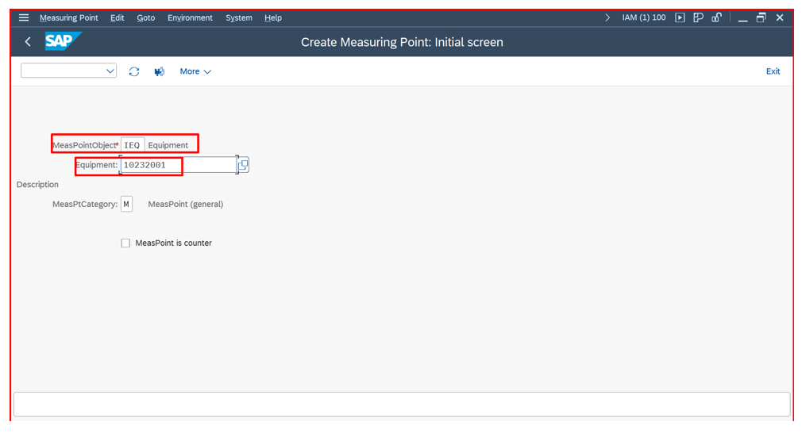

- Enter measuring position and description. In General data tab, enter the characteristics and press enter. Characteristic unit will be assigned as shown.

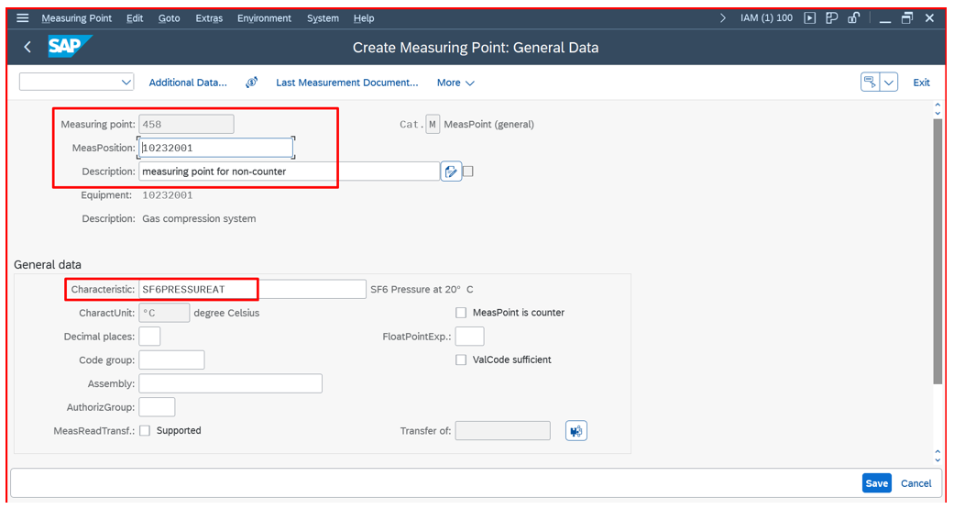
- In target value tab, enter the target value.

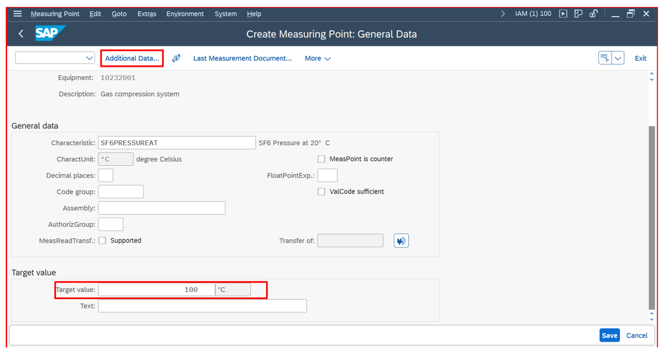

- Click on additional data, give upper range limit and lower range limit as required. Click on continue.

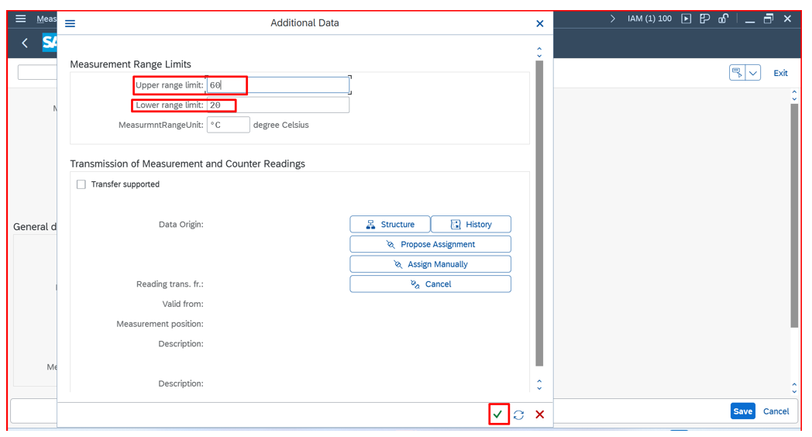

- Click on Save.

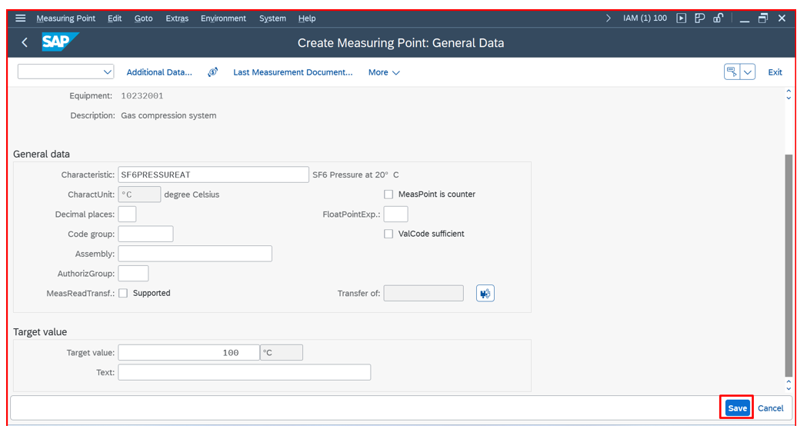

- Measuring Point 458 is created for non-counter as shown.

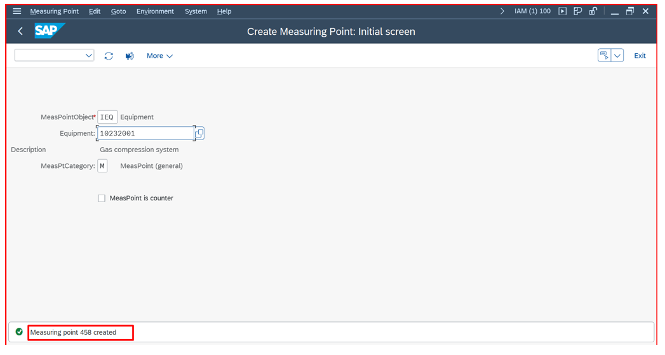

3. Measuring Point Creation for counter

3.1. Steps:

- Select measuring point object and enter object number. Check on Measuring point is counter. Click enter.
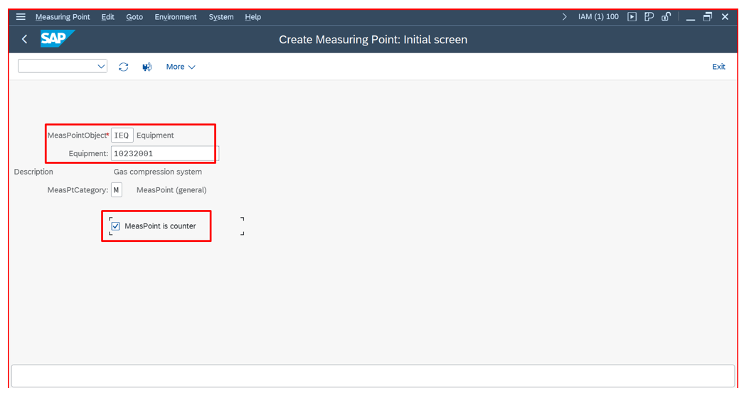

- Enter measuring position and description. In General data tab, enter the characteristics and press enter. Characteristic unit will be assigned as shown.
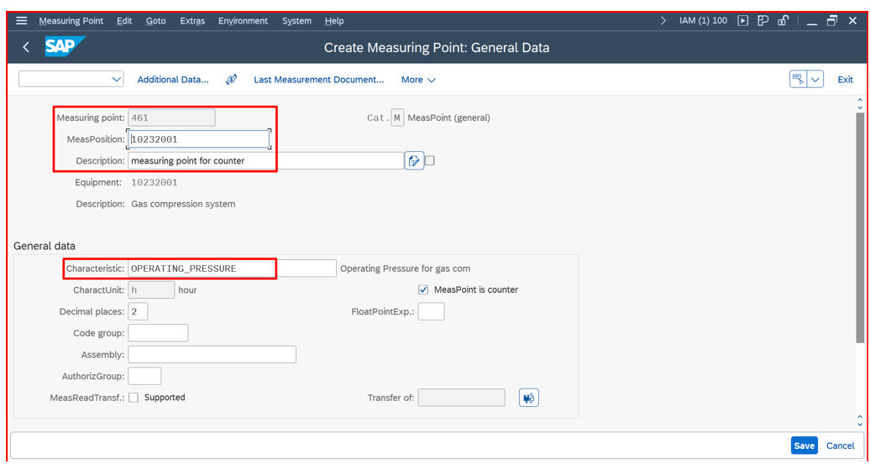
- In counter data tab, enter Counter Overflow reading value and annual estimate value as required. Click on save.

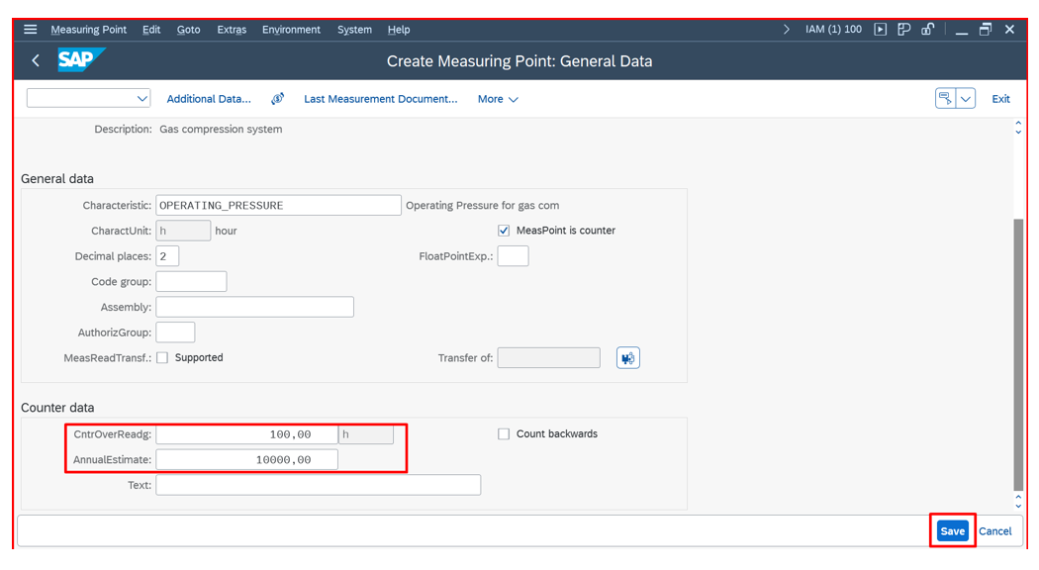

- Measuring point 461 is created for counter.

